* 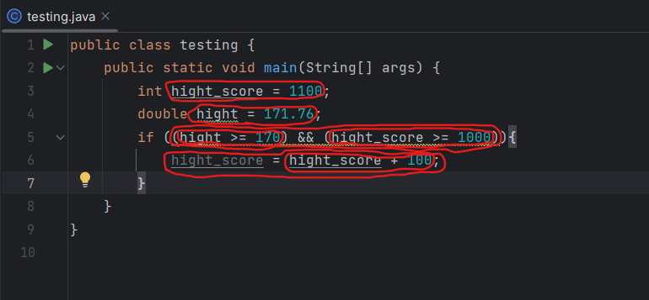**Notice that this code has 7 expressions**

Mind that “()” are not considered as a part of the expression.

* **We may also break the statement as follows:**

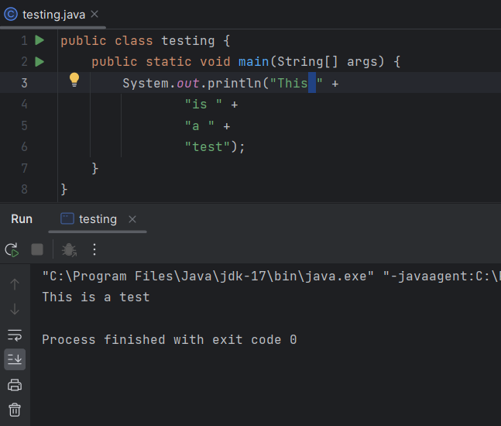

* **White space**

Whitespace is any extra spacing, horizontally or vertically, placed around java source code.

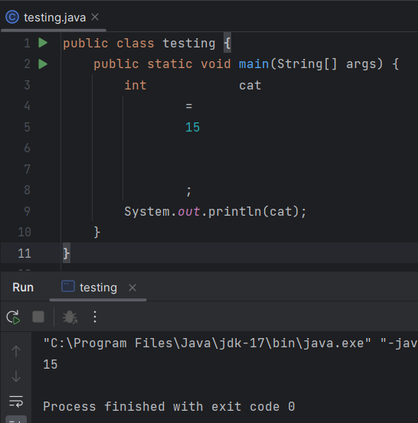

We also play crazy with adding white spaces and java is going to be happy with that…it will simply cut of the extra spaces…

Yet the best is to keep to the tradition since its more readable…

* **Indentation of code is not compulsory**

Yup… it’s not compulsory when it comes to java…

The purpose of it is just to make it more readable and to make it easier to understand the logical flow of the code…

* **Methods**

Keep in mind that there can't be methods inside methods as well as methods should be always included within the class…

* + **Parameters vs arguments**
    - **Parameters**

A parameter is the definition as shown in the method declaration…

* + - **Arguments**

The argument will be the value that’s passed to the method when we call it…

* + A call of a method that returns a value often acts as an expression or as a part of an expression (function) while calling a method that doesn’t return a value often acts as a statement (procedure).
  + You may also add a return keyword to stop Java to execute the statements after the it within the method…

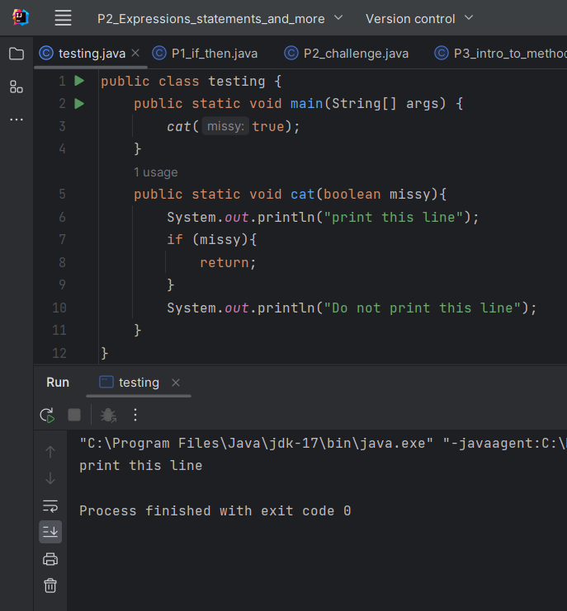

But mind that you should not mess things up this way

* You may have multiple methods with the same name as long as the parameters are different from each other…

This means that Java identifies a method not only by its name but by both its name and the parameters; this combination should be unique when it comes to a method

This is called the method signature…